Analysis Period: Through Q2 2026

Project Started On: July 2026

ASK

Stakeholder Request #1: I want to understand what’s driving our sales performance.

Questions I’d Ask:

What business decision are you hoping this analysis will support? (Business objective)

How are we defining sales performance? (Metric)

After identifying the highest performing product categories, would you like the analysis broken down further by region or customer segments? (Success Criteria)

Final Stakeholder Request:

Analyze product category performance to identify which categories contribute the most revenue and profitability, and recommend where the business should focus future sales efforts.

Stakeholder Request #2: I’m concerned our pricing strategy may be affecting profitability.

Questions I’d Ask:

What pricing decision are you hoping this analysis will help you make? (Business Objective)

Should we measure success using profitability, revenue, or a balance of both? (Metric)

Should we identify which product categories are most impacted by discounting?

What data is available regarding our product costs, promotions, or pricing history? (Data availability)

Final Stakeholder Request:

Analyze the relationship between discount percentages, revenue, and profitability to determine whether current pricing strategies are maximizing business performance.

Stakeholder Request #3: I want to understand how our sales performance is changing each quarter.

Questions I'd Ask:

What business decision are you hoping this trend analysis will support? (Business Objective)

Should we compare sales performance Quarter-over-Quarter, Year-over-Year, or both? If comparing Quarter-over-Quarter, should we compare against the immediately previous quarter or the same quarter from the previous year? (Timeframe & Comparison)

Should the analysis focus on overall company performance, or would you also like quarterly trends broken down by product category, region, or customer segment? (Scope)

What outcome would make this analysis useful? For example, identifying seasonal trends or forecasting future sales opportunities? (Success criteria)

Final Stakeholder Request:

Analyze Quarter-over-Quarter sales performance to identify revenue trends, seasonal patterns, and opportunities that can support future sales planning and business decision-making.

PREPARE
Prepared a realistic transactional sales dataset containing approximately 50,000 sales records with intentionally introduced data quality issues (duplicates, inconsistent formatting, missing values, and capitalization errors) to simulate a real-world business environment for data cleaning and sales analytics.
Table: Sales_Transactions_Spreadsheet.xlsx

PROCESS
Issue Identified | Tool/Function | Action Taken
Column size/width | Format: Autofit Column Width/Height | Resized all column widths and row heights to improve readability and presentation consistency.
Duplicate Records | Remove Duplicates, Sort & Review | Reviewed and removed 198 duplicate records.
Capitalization Errors/ Extra Spaces | =PROPER(TRIM(cell2)) | Standardized all categories/inconsistent formatting and removed trailing spaces.
Date Standardization | Cell Formatting | Validated and standardized date formatting across approximately 50,000 transaction records.
Number Standardization | Currency Number Format ($), Number format, Percent, Date format | Applied consistent number and currency formatting to columns that contained numeric values.
NULLS | Conditional Formatting: New Rule, Highlight cell value that contains a blank | Applied a rule to highlight blank cell values yellow to notify a blank cell.
Negative Values | Conditional Formatting: New Rule → Highlight cell value < 0 | Applied a rule to highlight negative cell values red with a red text to notify a negative value.

ANALYZE

Analyze product category performance to identify which categories contribute the most revenue and profitability, and recommend where the business should focus future sales efforts.
Key Findings (Validated Through Analysis)
Query 1 (Product Category Revenue & Profitability Performance)
- Software and Consulting were identified as the company's two largest revenue-generating product categories. Software generated approximately $69.2M in revenue and $39.2M in profit, resulting in a 56.8% profit margin, while Consulting generated approximately $66.6M in revenue and $29.7M in profit, with a 44.6% profit margin. Although both categories generated similar revenue, Software converted revenue into profit significantly more efficiently.
Query 2 (Regional Revenue & Profitability Performance)
- The West region was the company's strongest-performing market, generating approximately $77.7M in revenue and $38.8M in profit, resulting in the highest regional profit margin of 49.9%.
Query 3 (Product Category Revenue & Profitability by Region)
- A deeper regional analysis showed that Software within the West region generated approximately $24.5M in revenue and $15.1M in profit, achieving an outstanding 61.7% profit margin, confirming that the West region is a major contributor to Software's overall success.
Query 4 (Customer Segment Revenue & Profitability Performance)
- The Mid-Market customer segment generated the highest overall revenue (approximately $73.8M) and profit (approximately $31.6M), making it the company's most valuable identified customer segment.
- A small number of customer records contained missing customer segment classifications. These records should be corrected to improve future customer segmentation, reporting accuracy, and business decision-making.
Initial Business Insights

Continue Investing in Software
Continue prioritizing Software as the company's primary growth driver. It generates the highest revenue ($69.2M), the highest profit ($39.2M), and the strongest profit margin (56.8%), making it the company's most efficient product category.

Improve Consulting's Profitability
Although Consulting generated nearly the same in revenue ($66.6M) as Software, it produced approximately $9.5M less profit and a substantially lower 44.6% profit margin, which is 12.2% less than Software. Leadership should conduct further analysis to identify the factors contributing to Consulting's lower profitability.

- Investigate the West Region's Strong Performance
Analyze the West region's sales practices, customer relationships, and market conditions to determine why it generated $77.7M in revenue, $38.8M in profit, and the company's highest regional profit margin (49.9%). Successful strategies should be evaluated for expansion into lower-performing regions.

- Expand Mid-Market Customer Growth
Continue prioritizing the Mid-Market customer segment, which generated approximately $73.8M in revenue and $31.6M in profit, making it the company's highest-performing identified customer segment based on revenue and profit.

Conclusion
The analysis identifies Software as the company's strongest-performing product category, generating the highest revenue ($69.2M), profit ($39.2M) and profit margin (56.8%). Consulting remains a major revenue contributor at $66.6M but generates lower profit and profitability than Software, indicating a need for further analysis into the factors affecting its margins.
Regional analysis identified the West as the strongest-performing region, generating approximately $77.7M in revenue, $38.8M in profit, and a 49.9% profit margin. Further analysis showed that Software within the West generated approximately $24.5M in revenue and $15.1M in profit with a 61.7% margin, reinforcing the importance of both Software and the West region to overall performance.
The Mid-Market segment also generated the highest revenue and profit among the analyzed customer segments, with approximately $73.8M in revenue and $31.6M in profit. Based on these findings, future sales efforts should prioritize Software, with continued attention to the strong performance of the West region and Mid-Market customer segment. Further analysis should investigate Consulting's lower profitability and the factors contributing to the West's stronger performance.

2. Analyze the relationship between discount percentages, revenue, and profitability to determine whether current pricing strategies are maximizing business performance.
Key Findings (Validated Through Analysis)
Query 1 (Product Category Performance & Average Discount Analysis)
- The average discount percentage remained consistent across every product category at approximately 13%. This indicates that the company applies a relatively uniform discounting strategy regardless of product category. Since discount rates are nearly identical, differences in profitability are likely being driven by factors other than discounting alone, such as pricing structure, product costs, or customer demand.
- Software delivered the strongest overall business performance despite receiving the same average discount as every other product category. Software generated approximately 11.4K completed orders, $69.2M in revenue, $39.2M in profit, and achieved the highest 56.8% profit margin, demonstrating that it converts sales into profit more efficiently than any other product category.
- Consulting also performed strongly, generating approximately 10.2K completed orders, $66.6M in revenue, and $29.7M in profit, resulting in a 44.6% profit margin. Although Consulting generated revenue comparable to Software, its lower profitability suggests that factors beyond discount percentage may be reducing overall margins.
- Marketing Services, Hardware, and Office Supplies all received the same average discount (13%) but generated fewer completed orders, lower revenue, and substantially lower profit margins. Office Supplies performed the weakest, recording only 6.7K completed orders and a 15.7% profit margin, indicating that applying the same discount strategy across all product categories does not produce consistent business performance.
Query 2 (Product Category Performance by Discount Range)
- Lower discount levels produced the strongest combination of order volume, revenue, profit, and profit margin across all product categories. Within the under-10% discount range, Software generated approximately 4.1K completed orders, $27.1M in revenue, $16.5M in profit, and a 61.0% profit margin. Consulting generated approximately 3.6K completed orders, $28.0M in revenue, $14.2M in profit, and a 50.7% profit margin. These results show that both categories performed most efficiently when discounts remained low.
- Profit margins declined steadily as discounts increased. Consulting’s profit margin fell from 50.7% at discounts under 10% to 27.8% at discounts of 30% or more. Software remained the most resilient category, but its margin still declined from 61.0% to 39.4% across the same discount ranges.
- Aggressive discounting created the greatest financial risk for lower-margin categories. Hardware’s profit margin declined from 33.8% under low discounts to –1.7% at discounts of 30% or more, resulting in an approximately $36,000 loss. Office Supplies experienced an even larger decline, falling from a 26.5% margin to –13.7%, producing an approximately $107,000 loss at the highest discount level.
- Marketing Services also experienced considerable margin erosion, declining from 43.2% under low discounts to 15.7% at discounts of 30% or more. This confirms that high discounting reduces profitability across the portfolio, even when the category remains profitable.
Query 3 (High-Discount Profitability Risk by Product Category)
- Office Supplies and Hardware are the primary contributors to poor financial performance among transactions receiving discounts of approximately 35%, making them the highest pricing-risk categories. Office Supplies generated only 681 completed orders, $768.9K in revenue, and recorded a loss of $106.5K, resulting in a -13.85% profit margin. Hardware generated 810 completed orders, $2.09M in revenue, but also produced a loss of $36.2K, resulting in a -1.74% profit margin. These findings indicate that discounts above 30% significantly reduce profitability for these product categories. Leadership should restrict deep discounts for Office Supplies and Hardware or require additional approval before offering them to reduce financial losses and protect overall profitability. This analysis further demonstrates that the company's current discounting strategy is not maximizing profitability at higher discount levels and supports implementing category-specific discount controls rather than broad discounting policies.

Initial Business Insights
1. Discounting does not appear to be the primary driver of profitability.
Because every product category receives approximately the same average discount (13%), the large differences in revenue and profit margins are likely influenced by other factors, including pricing structure, product costs, customer demand, or operational efficiency. Leadership should investigate these drivers before making broad discounting changes.

2. Evaluate Software's Pricing Model for Potential Application Across Other Categories
Software generated the highest revenue, profit, and profit margin while receiving the same average discount as every other category. Leadership should analyze Software's pricing model to determine whether similar pricing strategies can be applied to other product categories.

3. Investigate the Drivers of Low Product Profitability
Hardware and Office Supplies generate considerably lower profit margins despite receiving the same discount percentage. Leadership should evaluate whether pricing, product positioning, production costs, or customer demand are limiting profitability.

4. Implement Category-Specific Discount Controls
The results indicate that the company's current discounting strategy is not maximizing profitability at higher discount levels. Discounts under 10% generated the strongest financial outcomes, while margins consistently weakened as discounts increased. Leadership should avoid applying broad, high-percentage discounts and establish category-specific discount controls. Discounts of 30% or more should be restricted for Hardware and Office Supplies because those transactions generated losses. Consulting and Marketing Services should also require additional approval for deeper discounts, while Software offers greater pricing flexibility because it remains profitable across all discount levels.
Conclusion
These findings confirm that the company's current discounting strategy is not consistently maximizing business profitability at higher discount levels and support implementing category-specific discount controls rather than broad discounting policies. Transactions receiving discounts below 10% generated the strongest financial results, while profitability consistently declined as discount levels increased. Office Supplies and Hardware experienced financial losses at discount levels above 30%, indicating that broad discounting strategies are negatively impacting profitability for these categories. In contrast, Software remained profitable across every discount range, suggesting greater pricing flexibility.
Overall, these findings support implementing category-specific discount strategies rather than applying uniform discounts across the business. By shifting from a broad discounting strategy to category-specific pricing policies, leadership can better protect profit margins while maintaining long-term revenue growth across the business.

3. Analyze Quarter-over-Quarter sales performance to identify revenue trends, seasonal patterns, and opportunities that can support future sales planning and business decision-making.
Key Findings (Validated Through Analysis)
Query 1 (Quarterly Sales & Profitability Performance)

• Sales activity consistently accelerated from Q1 to Q2 from 2023 through 2025, establishing a recurring second-quarter growth pattern. Completed orders increased from approximately 2.1K to 2.5K in 2023, 2.4K to 2.9K in 2024, and 2.6K to 3.4K in 2025, indicating historically stronger customer demand during Q2.

• Higher Q2 sales activity (Revenue) did not consistently translate into stronger profitability. Revenue increased from Q1 to Q2 in 2023–2025, but profit margins remained approximately flat in 2023 (.1% increase), declined slightly in 2024 (-0.3%), and declined substantially in 2025, from 50.2% to 41.6% (-8.6%).

• 2026 broke from the historical Q2 growth pattern. Compared with Q1, Q2 completed orders decreased by approximately 600, revenue declined by approximately $9.3M, profit fell by approximately $4.1M, and profit margin decreased from 43.0% to 41.6%.
This represents the first year in the analysis where the business failed to achieve its typical second-quarter growth, suggesting a meaningful shift in customer demand or business performance that warrants further investigation.
Query 2 (Quarterly Product Category Performance Q1 & Q2 Only)

Software and Consulting consistently contributed to Q2 sales growth from 2023 through 2025. Their combined completed-order volume increased from approximately 1.0K to 1.2K in 2023, 1.2K to 1.4K in 2024, and 1.3K to 1.7K in 2025.
- Marketing Services was the largest contributor to Q2 order growth in 2024, increasing from 422 completed orders in Q1 to 566 in Q2, a gain of 144 orders (34.1%). This indicates that Marketing Services also played a particularly important role in accelerating Q2 sales activity during 2024.

Stronger sales activity did not consistently improve profitability across product categories. Hardware generated higher absolute profit in Q2 from 2023 through 2025, but its profit margin declined each year. Office Supplies showed the clearest 2025 disconnect, with completed orders increasing from 399 to 517 while profit declined from approximately $100K to $90K and profit margin fell from 20.4% to 12.7%.
- The 2026 Q2 decline was broad across major product categories. Software, Consulting, Marketing Services, and Hardware all experienced declines in completed orders, revenue, and profit, while Hardware also experienced substantial margin deterioration from 32.57% to 20.25%. Meanwhile, Software, Consulting, and Marketing Services maintained or slightly improved their margins despite declining revenue.
Query 3 (Quarterly Regional Performance)
- The Northeast was the largest regional contributor to the 2025 Q2 profit decline. Profit decreased from approximately $2.30M to $1.30M, a decline of roughly $996K, while profit margin fell from 53.5% to 42.3%.
- The 2025 profitability weakness was geographically broad rather than isolated to one region. The South's profit declined from approximately $1.66M to $1.22M, a decrease of about $448K, while its profit margin fell from 42.3% to 35.0%. The Midwest's profit declined from approximately $1.35M to $968K, a decrease of about $377K, while its profit margin fell from 43.4% to 37.1%. Overall, three of the four regions experienced declining total profit in Q2.
- The West was the only region to generate higher total profit in Q2 2025, but profitability relative to revenue weakened. Profit increased from approximately $2.92M to $3.48M, an increase of about $563K, while revenue increased from approximately $5.05M to $7.59M. However, profit margin declined from 57.7% to 45.9%, an 11.8 percentage-point decrease.
- Regional performance confirms that the 2025 profitability weakness was widespread but affected regions differently. The Northeast contributed the largest absolute profit decline, while the South and Midwest also experienced lower profit and margins. The West was the only region to increase total profit, but its substantial margin deterioration indicates that stronger sales growth did not translate into proportional profitability growth.
Query 4 (2025 Regional Product Category Performance)
- Hardware performance varied significantly by region, with the Midwest showing the clearest decline in sales and profitability. The Midwest was the only region where Hardware experienced declines in both revenue and total profit, with revenue falling from approximately $469K in Q1 to $269K in Q2, while profit declined from approximately $112K to $48K, a decrease of about $64K. Profit margin also fell from 23.9% to 17.9%. In contrast, Hardware revenue and profit increased in the Northeast, South, and West. However, the Northeast experienced the largest Hardware margin deterioration, falling from 27.1% to 19.6%, despite revenue increasing from approximately $201K to $426K and profit increasing from approximately $54K to $84K. This shows that Hardware's overall Q2 profit growth masked meaningful differences in regional performance. This adds important context to the earlier Hardware finding: Hardware's overall Q2 profit growth masked meaningful regional differences. The Midwest experienced an actual contraction in Hardware performance, while the Northeast generated growth at substantially weaker profitability.
- Office Supplies experienced margin compression across all four regions despite stronger Q2 sales activity. Every region generated higher completed orders and revenue in Q2, yet profit margins declined across the Midwest from 9.5% to 7.9%, Northeast from 21.7% to 17.8%, South from 12.2% to -5.5%, and West from 32.2% to 30.2%. Although the Midwest, Northeast, and West remained profitable, their declining margins indicate that the additional Q2 Office Supplies revenue was generally being generated less profitably than in Q1. This shows that Office Supplies' profitability deterioration was geographically widespread rather than isolated to one region.
- The South represented the strongest Office Supplies profitability warning. Completed orders increased from 107 in Q1 to 126 in Q2, while revenue increased from approximately $123K to $170K. Despite that stronger sales activity, profit fell from approximately $15K to a $9.3K loss, while profit margin deteriorated from 12.2% to -5.5%, a decline of approximately 17.7 percentage points. The South therefore did not simply generate Office Supplies sales at a lower margin, but it became unprofitable despite selling more, making it a particularly important area for further investigation. This provides a more specific explanation for the broader profitability weakness identified in the earlier queries. Quarterly Regional Performance analysis (Query 3) showed that the South experienced declining overall profitability, while the 2025 Regional Product Category Performance analysis (Query 4) identifies South region’s Office Supplies as a particularly important area of concern because increased customer demand and revenue were accompanied by an operating loss.
Query 5 (Office Supplies Profitability Drivers by Region – 2025 Q1 & Q2)
- Rapid cost growth was the strongest financial driver identified behind the South’s Office Supplies profitability deterioration, while higher discounting added further margin pressure. From Q1 to Q2, completed orders increased from 104 to 122 and revenue increased from approximately $121.9K to $161.9K, an increase of about 32.8%. However, total cost increased much faster, rising from approximately $107.1K to $172.4K, an increase of about 60.9%. Consequently, profit fell from approximately $14.8K to a $10.5K loss, while profit margin deteriorated from 12.1% to -6.5%. This shows that the South's profitability problem was not caused by weak sales activity, but costs were growing substantially faster than the revenue generated.
- The South’s cost-to-revenue ratio exceeded 100% in Q2, while higher discounting created additional profitability pressure. The South's cost-to-revenue ratio increased from 87.9% in Q1 to 106.5% in Q2, meaning Office Supplies costs ultimately exceeded the revenue being generated. At the same time, average discounting increased from 10.82% to 14.92%, the largest increase among the four regions. Together, these results indicate that stronger sales were becoming increasingly expensive and less profitable to generate, with rapid cost growth representing the primary financial concern and increased discounting adding further margin pressure.
- The South was the clear regional outlier despite Office Supplies margin compression occurring across all four regions. Profit margins declined from 9.2% to 7.9% in the Midwest, 21.8% to 17.9% in the Northeast, 12.1% to -6.5% in the South, and 32.4% to 30.2% in the West. While the Midwest, Northeast, and West remained profitable, the South was the only region where costs exceeded revenue and profit became negative. This shows that Office Supplies faced widespread profitability pressure in Q2, but the South's deterioration was substantially more severe than the broader category trend.
Query 6 – South Office Supplies Product-Level Profitability Drivers (2025 Q1 & Q2)
- The South’s Office Supplies profitability weakness was concentrated among specific products rather than being uniform across the category. Query 5 showed that completed orders increased from 104 to 122 and revenue increased from approximately $121.9K to $161.9K, yet profit shifted from approximately $14.8K to a $10.5K loss. At the product level, some products remained profitable while others shifted from positive profitability in Q1 to losses in Q2, indicating that specific loss-generating products contributed disproportionately to the South’s overall deterioration.
- Desk Organizer 568 provides a clear example of product-level deterioration associated with substantially higher discounting. In Q1, the product generated approximately $3,059 in revenue, $648 in profit, and a 21.18% profit margin. In Q2, completed orders increased from 1 to 3, yet revenue declined to approximately $1,868, while the product generated a $399 loss and its profit margin fell to -21.36%. At the same time, its average discount increased from 5% to 33%, suggesting that heavier discounting may have contributed to the deterioration, although the results do not establish discounting as the sole cause.
- Higher discounting was associated with weak profitability for several products, but discounting did not explain every loss. For example, Desk Organizer 342 carried an average discount of approximately 60% in Q2, generated a $172 loss, and had costs reaching approximately 250% of revenue. However, other products generated losses despite relatively low or no discounting. This indicates that both discounting and underlying product costs were associated with the profitability pressure, rather than discounting alone explaining the losses.
- High cost-to-revenue ratios were a major warning sign among loss-generating products. Several products, including Presentation Binder 688, Desk Organizer 752, and Desk Organizer 833, had costs exceeding 100% of revenue. Once product costs exceed the revenue generated, additional sales volume cannot produce positive profitability under the existing economics. This helps explain why the South could generate more Office Supplies orders and approximately $40K more revenue overall in Q2 while still moving from a $14.8K profit to a $10.5K loss.
Overall Insight: The South’s Office Supplies profitability problem appears to be driven by a product-level mix of excessive costs and, for certain products, aggressive discounting rather than weak customer demand alone. The business should investigate the products generating the largest Q2 losses and determine whether their pricing, discount levels, or underlying costs should be adjusted.
Query 7: South Office Supplies Product Profit Change Ranking (2025 Q1 vs Q2)
Key Findings:
- Presentation Binder 926 was by far the largest negative contributor to South Office Supplies profitability. Its profit declined by approximately $12,927, moving from a $1,498 profit in Q1 to an $11,429 loss in Q2. This single product experienced a substantially larger profit decline than the other products identified, showing that the South’s profitability deterioration was heavily concentrated rather than evenly distributed across Office Supplies products.
- Presentation Binder 926’s deterioration was primarily associated with costs increasing substantially faster than revenue. Revenue increased from approximately $6,288 in Q1 to $40,850 in Q2, but costs surged from approximately $4,791 to $52,278. As a result, its profit margin deteriorated from 23.82% to -27.98%. Its average discount also increased from 5% to 13%, suggesting additional pricing pressure, but the fact that Q2 costs exceeded revenue by approximately $11.4K makes the product’s cost structure the clearest financial warning.
- The remaining major declines were considerably smaller, further demonstrating how concentrated the profitability problem was. Desk Organizer 568 experienced the second-largest decline, with profit decreasing by approximately $1,047, from a $648 profit to a $399 loss. Toner Cartridge 892 followed with an approximately $945 decline, moving from a $224 profit to a $721 loss. Together, these results show that a relatively small group of products accounted for some of the most significant Q2 profitability deterioration.
- The product ranking confirms that South Office Supplies' profitability decline was not simply the result of weaker customer demand. Presentation Binder 926 generated approximately $34.6K more revenue in Q2 than Q1, yet its profit deteriorated by approximately $12.9K because costs increased by approximately $47.5K. Combined with the declines in Desk Organizer 568 and Toner Cartridge 892, the results indicate that product-level cost growth and, for some products, increased discounting were associated with the category’s Q2 profitability decline despite stronger overall sales activity.
Initial Business Insights
- Prioritize profitability over sales volume when planning future Q2 growth. Historical Q2 demand has generally been strong, but the 2025 results show that higher revenue does not necessarily produce stronger profitability when margins deteriorate.

- Review South Office Supplies as a priority area. Despite higher Q2 orders and revenue, the category became unprofitable in the South. Leadership should investigate its pricing, cost structure, and discount strategy before pursuing additional sales growth.

- Focus corrective action on the highest-loss products rather than applying broad category-wide changes. Presentation Binder 926 should receive immediate attention, followed by Desk Organizer 568 and Toner Cartridge 892, because the profitability decline was concentrated among specific products.

- Establish profitability controls around product costs and discounting. Products with costs approaching or exceeding revenue should be flagged for review, while higher discount levels should be evaluated to ensure additional sales are generating acceptable margins.
- Investigate the 2026 Q2 sales decline separately from the 2025 profitability issue. Unlike prior years, 2026 experienced declining Q2 orders and revenue, suggesting a potential shift in customer demand that warrants further analysis.
Conclusion
The analysis shows that stronger sales activity alone does not guarantee stronger business performance. While Q2 historically generated higher demand, 2025 revealed significant profitability pressure, particularly within South Office Supplies, where costs grew faster than revenue and several products generated substantial losses. Product-level analysis further showed that the deterioration was concentrated among a small number of high-loss products, with Presentation Binder 926 representing the largest negative contributor.
Overall, leadership should focus on improving product-level cost efficiency, evaluating pricing and discount strategies, and protecting profit margins before pursuing additional sales growth. The separate decline in Q2 2026 sales activity should also be investigated to determine whether the business is experiencing a broader change in customer demand.

SHARE
Business Problem #1

Stakeholder Request: I want to understand what’s driving our sales performance.

- Product Category Revenue & Profitability Performance
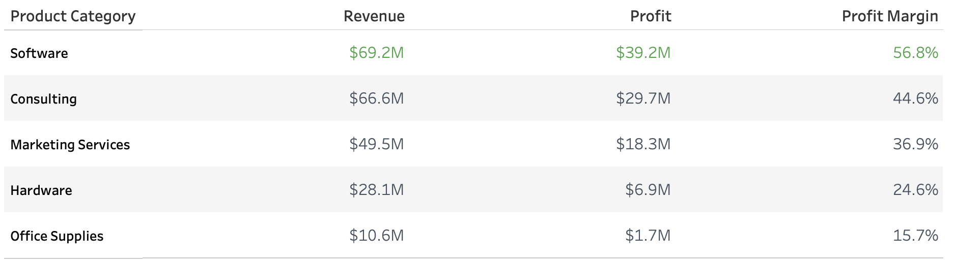
Key Insight
- Software is the strongest overall category, generating $69.2M in revenue and $39.2M in profit while maintaining the highest profit margin at 56.8%.

- Regional Performance
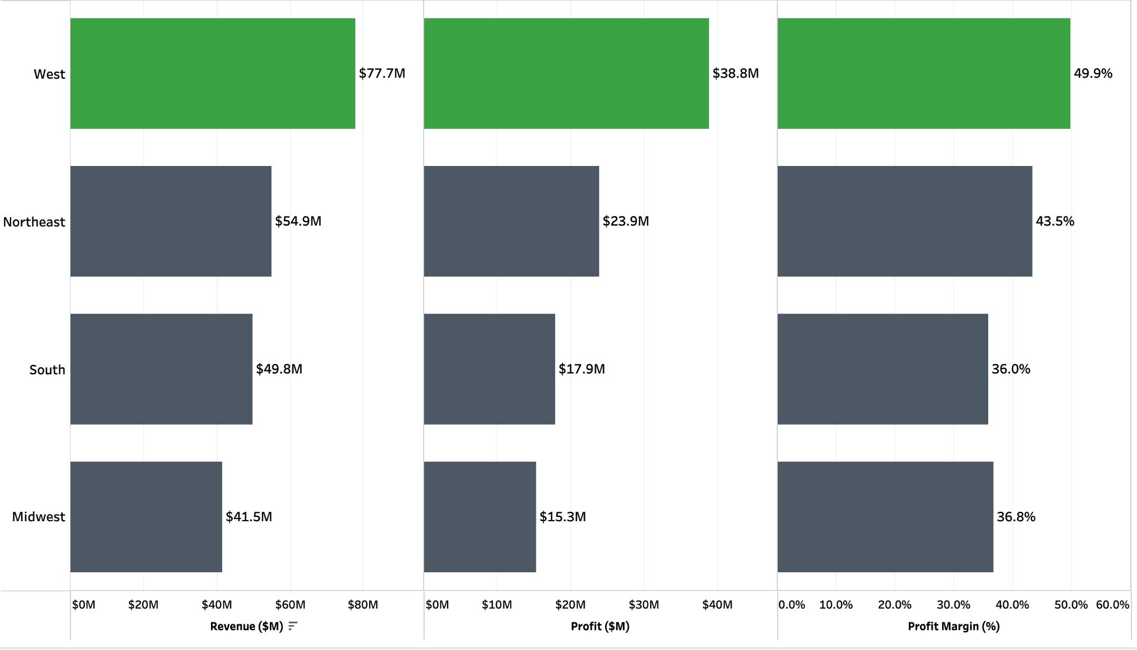
Key Insight
- The West leads all regions with $77.7M in revenue and $38.8M in profit, while also producing the highest profit margin at 49.9%.

- West Product Category Performance
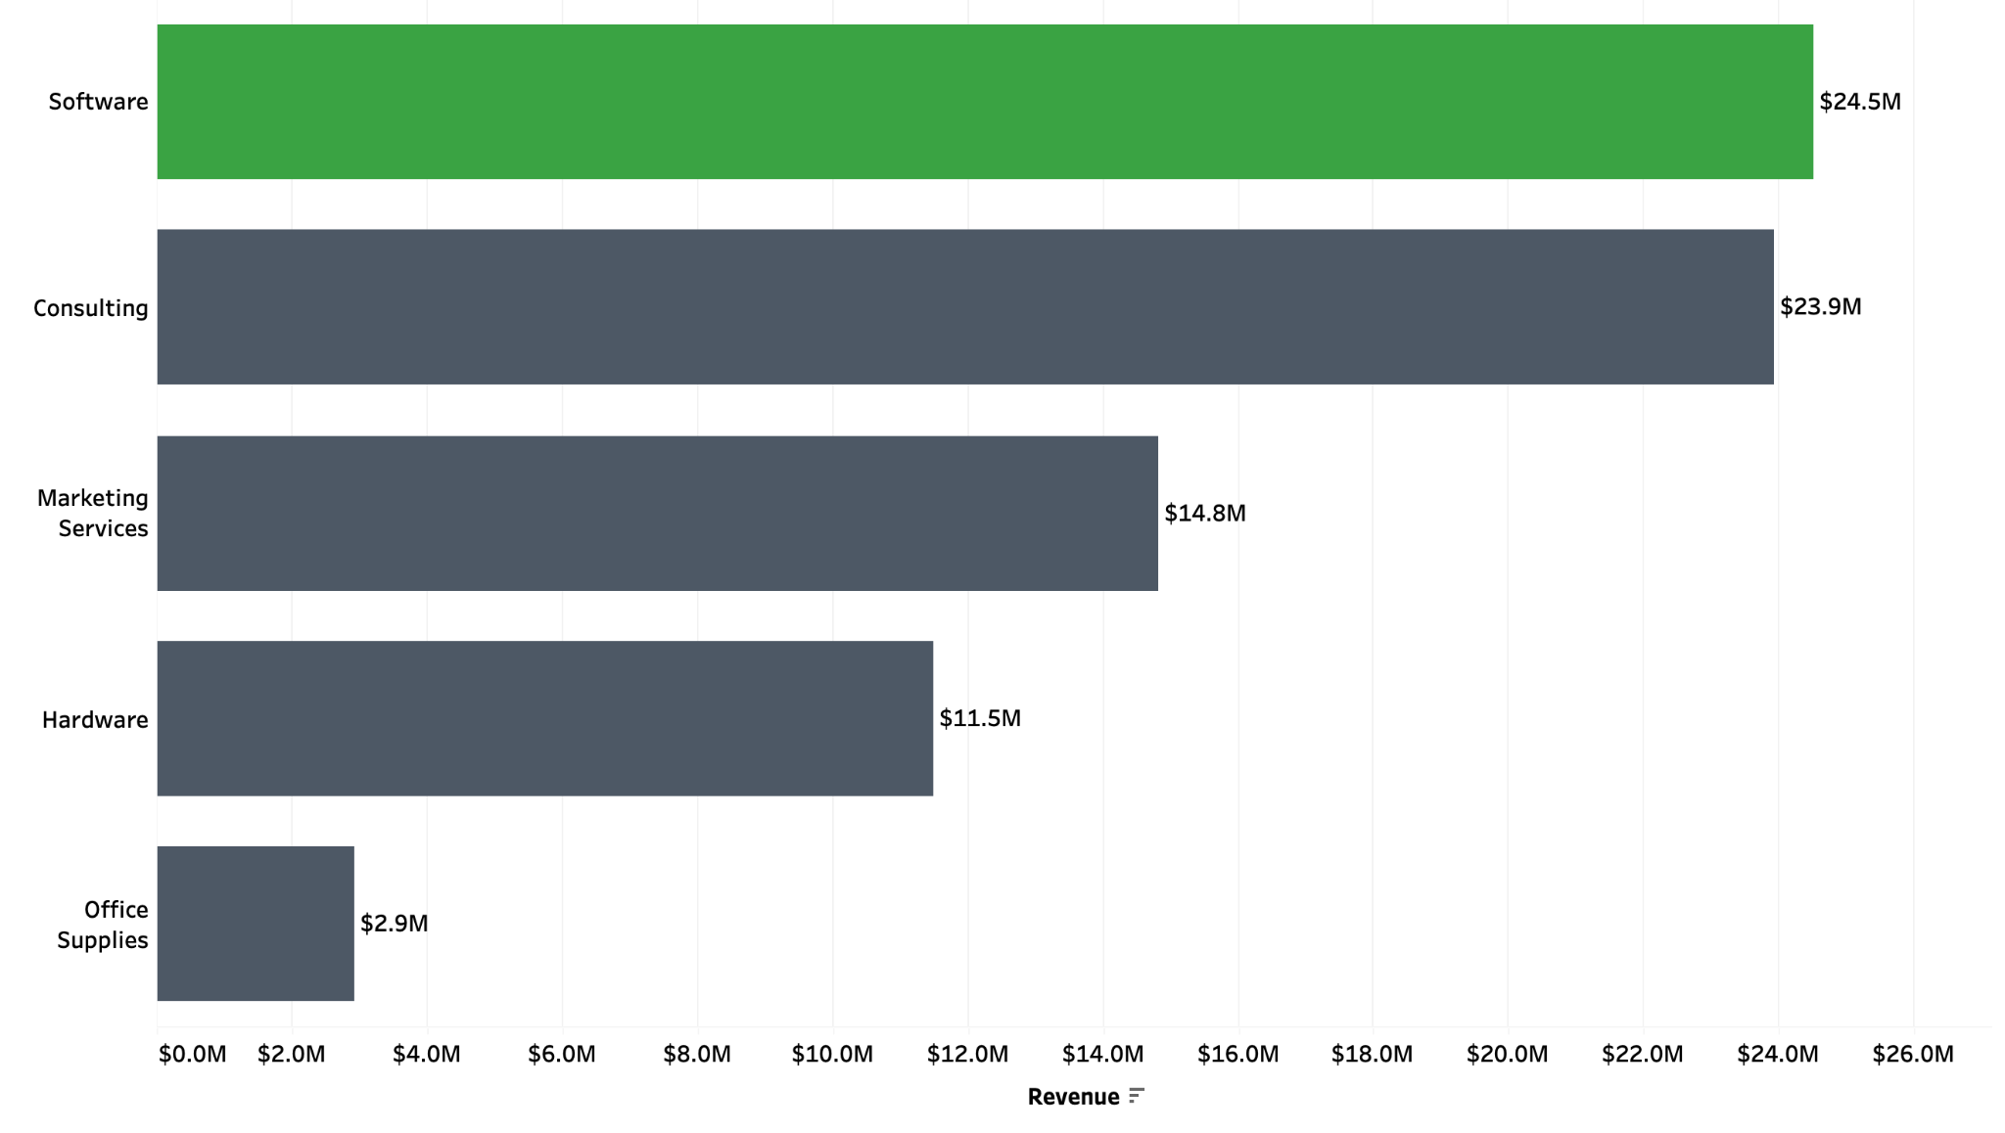
Key Insight
- Software generates the most revenue within the West at $24.5M, narrowly ahead of Consulting at $23.9M.

Business Takeaway
- Software and the West represent the strongest areas of current performance, while Consulting's lower profitability despite strong revenue presents an opportunity for further investigation. Mid-Market customers also warrant additional analysis as a potential source of future sales growth.

Business Problem #2

Stakeholder Request: I’m concerned our pricing strategy may be affecting profitability.

- Average Discount by Product Category
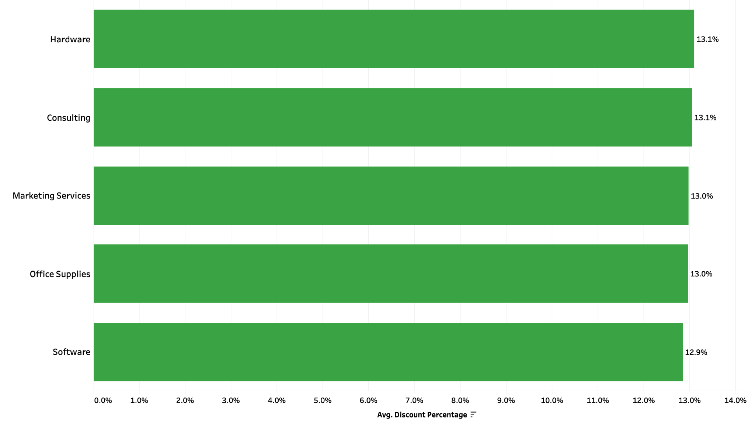
Key Insight
- Average discount rates are nearly identical across product categories, ranging from 12.9% to 13.1%, indicating similar overall discounting levels across the business.

- Profit Margin by Discount Range and Product Category
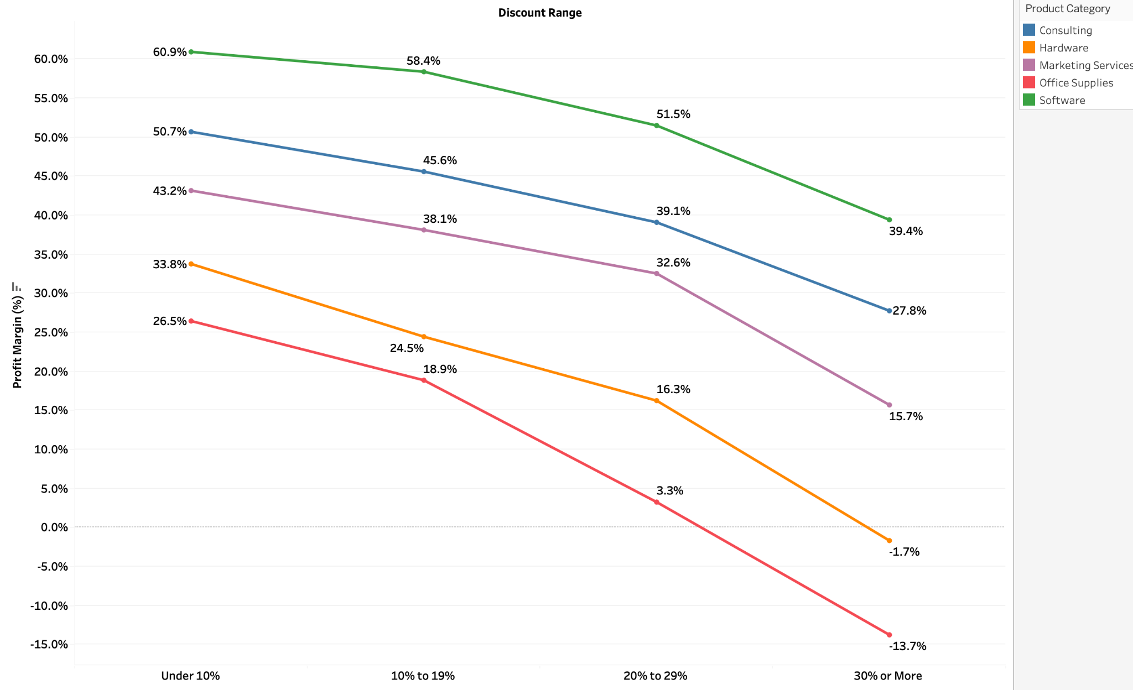
Key Insight
- Profit margins decline as discount levels increase across every product category. Hardware and Office Supplies face the greatest risk at discounts of 30% or more, while Software maintains comparatively strong margins.

- Revenue by Discount Range
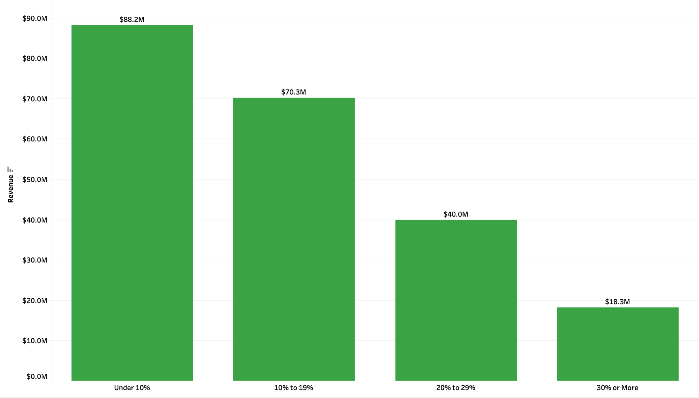
Key Insight
- Revenue is concentrated among lower-discount transactions, with $88.2M generated at discounts under 10% compared with $18.3M at discounts of 30% or more.

- Profit by Product Category at 30%+ Discounts
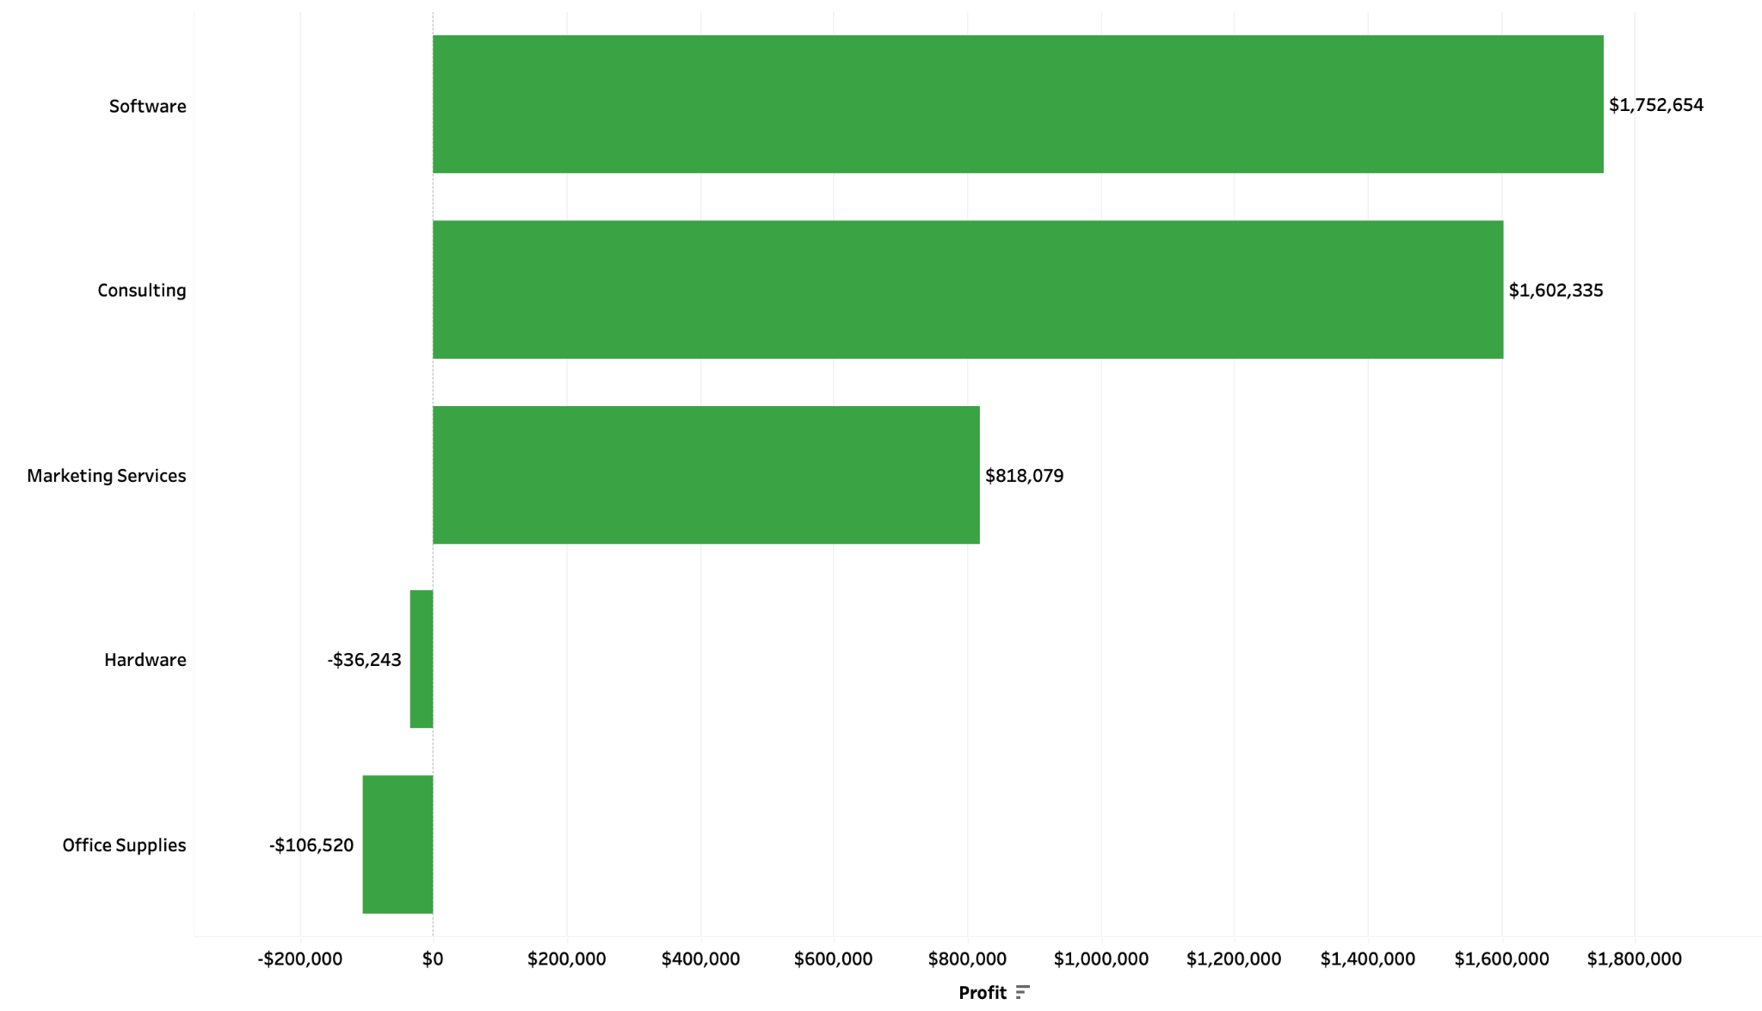
Key Insight
- At discount levels of 30% or more, Software, Consulting, and Marketing Services remain profitable, while Hardware (-$36.2K) and Office Supplies (-$106.5K) generate losses.

Business Takeaway
- Higher discount levels are associated with lower profitability, but the impact varies significantly by product category. While Software and Consulting remain profitable even at discounts of 30% or more, Hardware and Office Supplies become unprofitable. This suggests that a uniform discounting strategy may expose lower-margin categories to unnecessary profitability risk.

Business Problem #3

Stakeholder Request: I want to understand how our sales performance is changing each quarter.

- Q1 vs. Q2 Completed Orders Trend 2023-2026
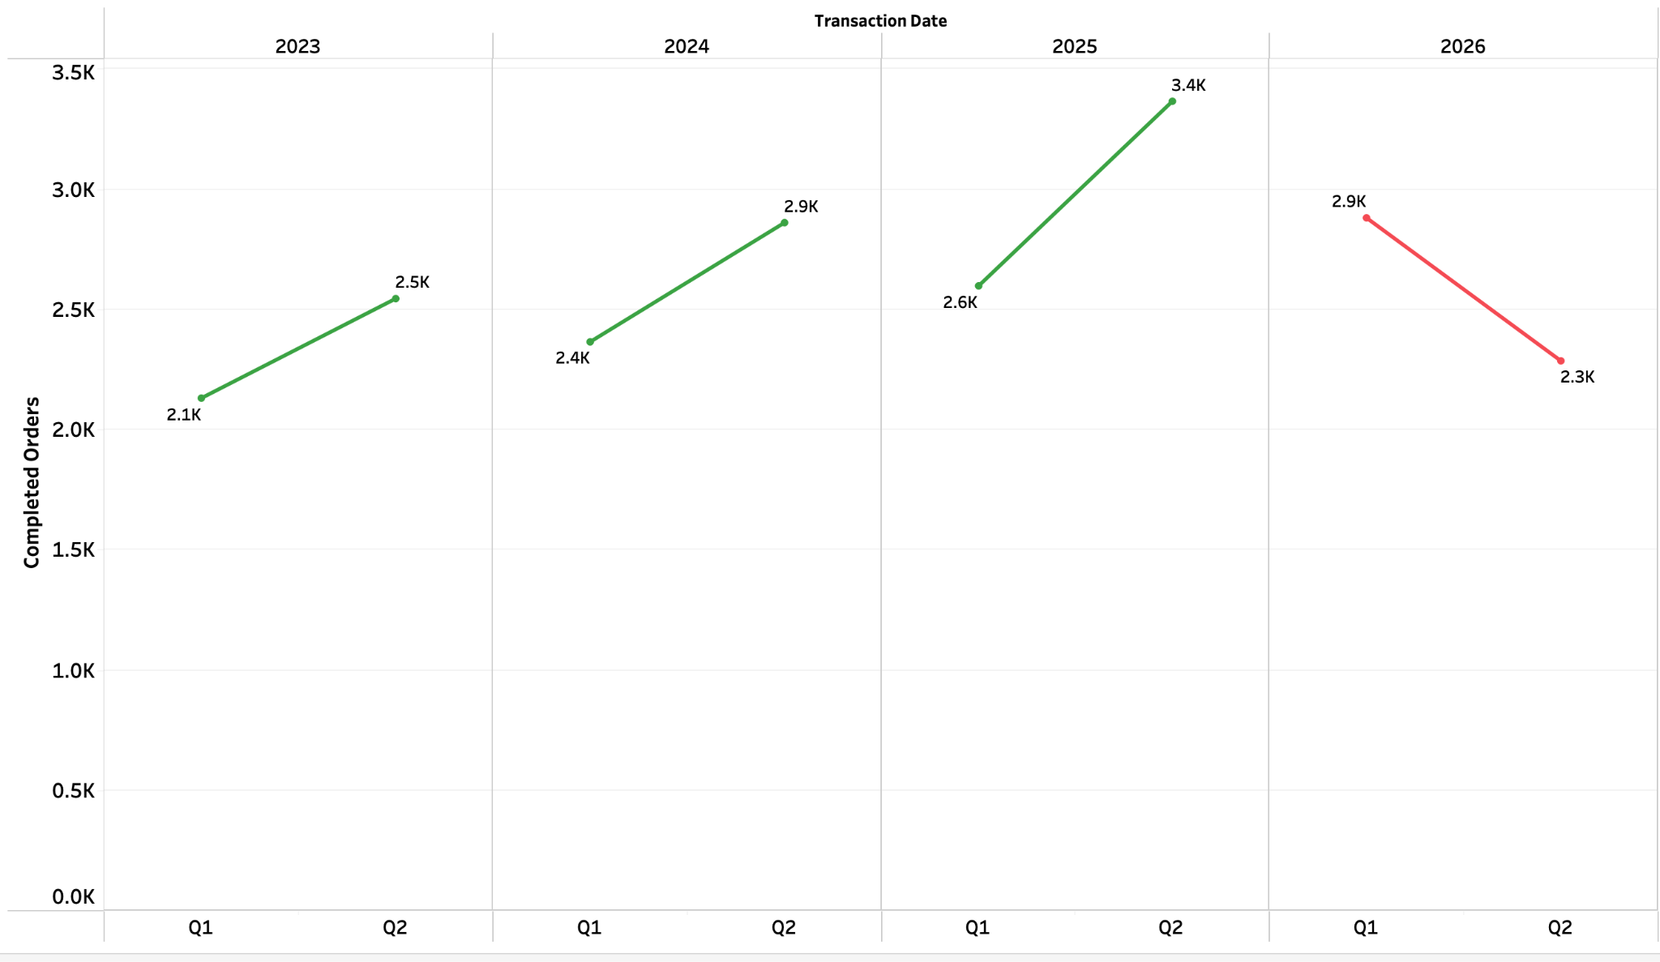
Key Insight
- Completed orders increased from Q1 to Q2 each year from 2023–2025. In 2026, the pattern reversed, with orders falling from approximately 2.9K to 2.3K, signaling a meaningful shift in sales performance.

- Q1 vs. Q2 Revenue & Profit Margin 2023-2026
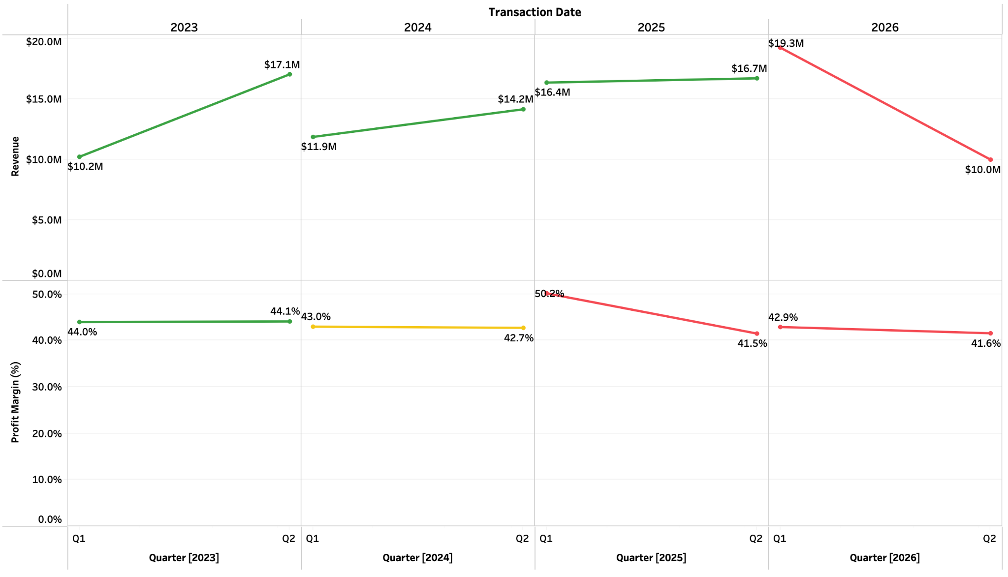
Key Insight
- Revenue growth did not consistently translate into stronger profitability. Profit margin weakened despite Q2 revenue growth in 2024 and 2025, while 2026 saw both revenue and margin decline, from $19.3M to $10.0M and 42.9% to 41.6%, respectively.

- Q1 vs. Q2 Completed Orders by Product Category (2023–2026)
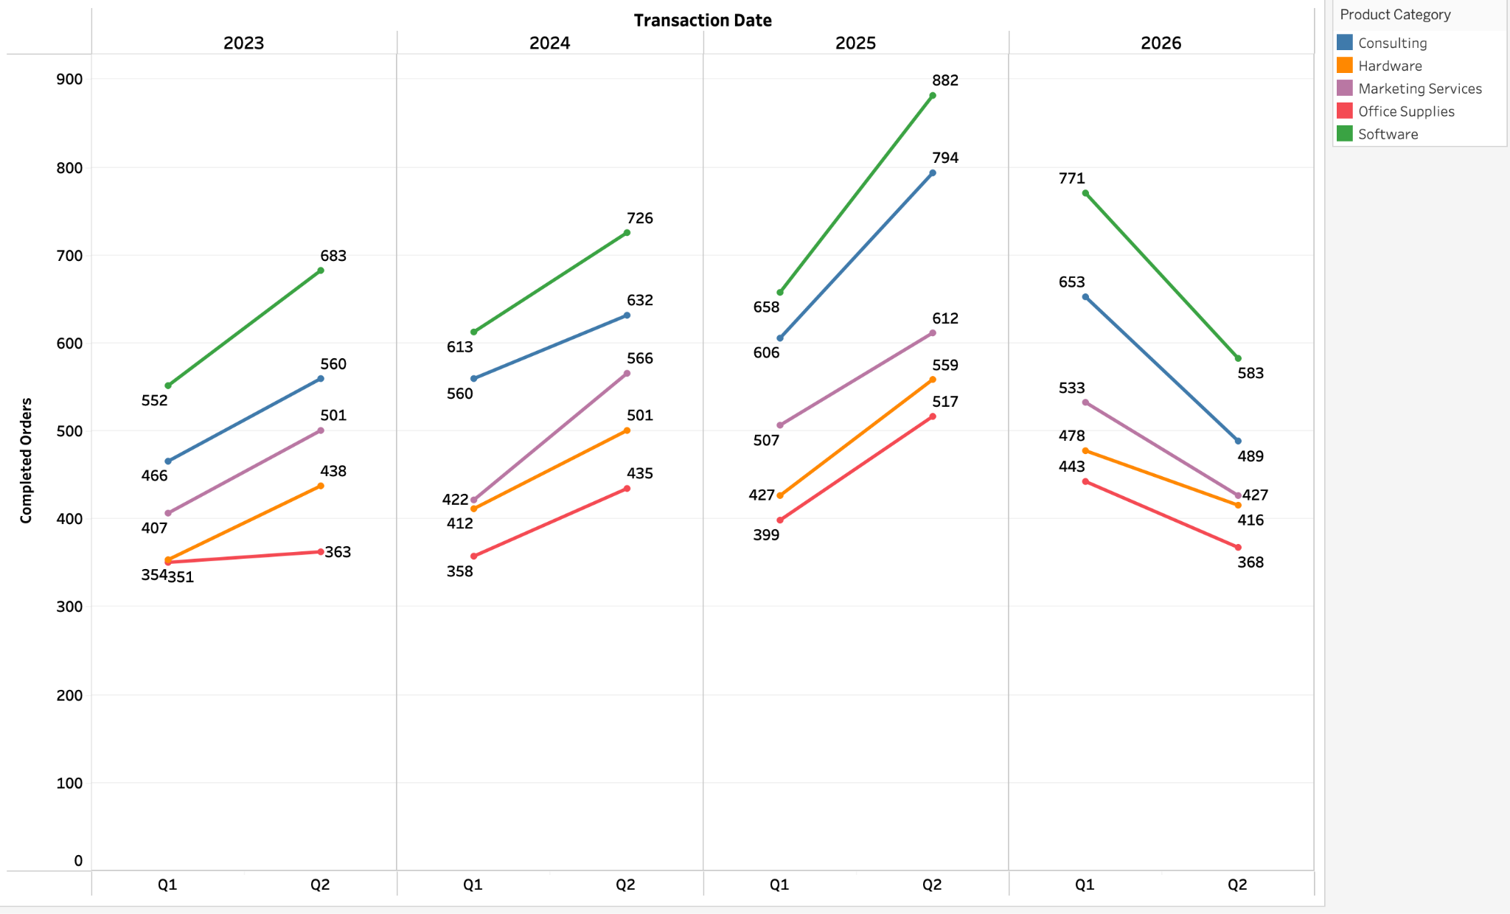
Key Insight
- From 2023–2025, every product category experienced Q2 order growth. In 2026, all five categories declined, indicating the slowdown was broad-based rather than isolated to one category.

- 2025 Q1 vs. Q2 Regional Profit Trend
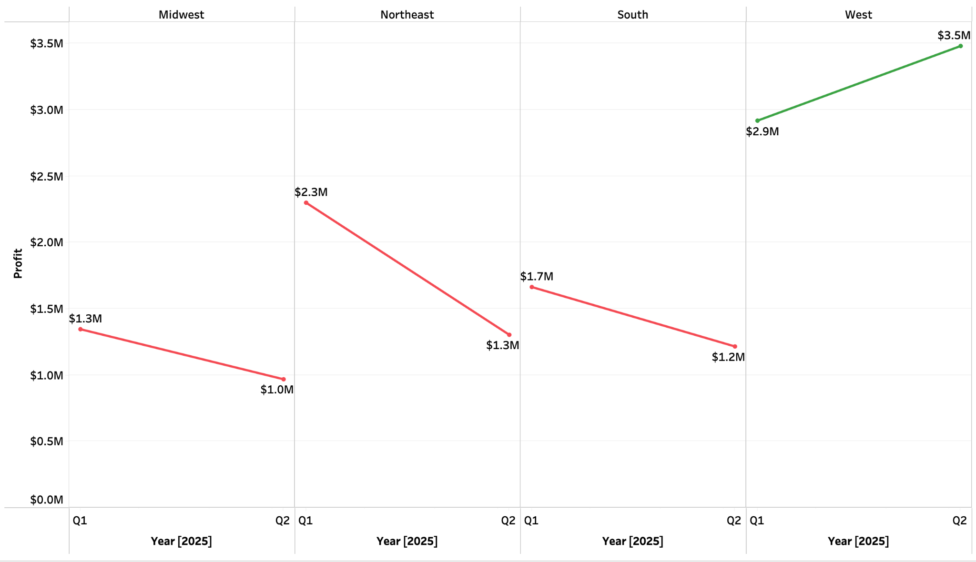
Key Insight
- In 2025, profit declined from Q1 to Q2 in three of four regions. The Northeast experienced the largest decline, while the West was the only region to increase profit.

- South Office Supplies Profitability Drivers — 2025 Q1 vs. Q2
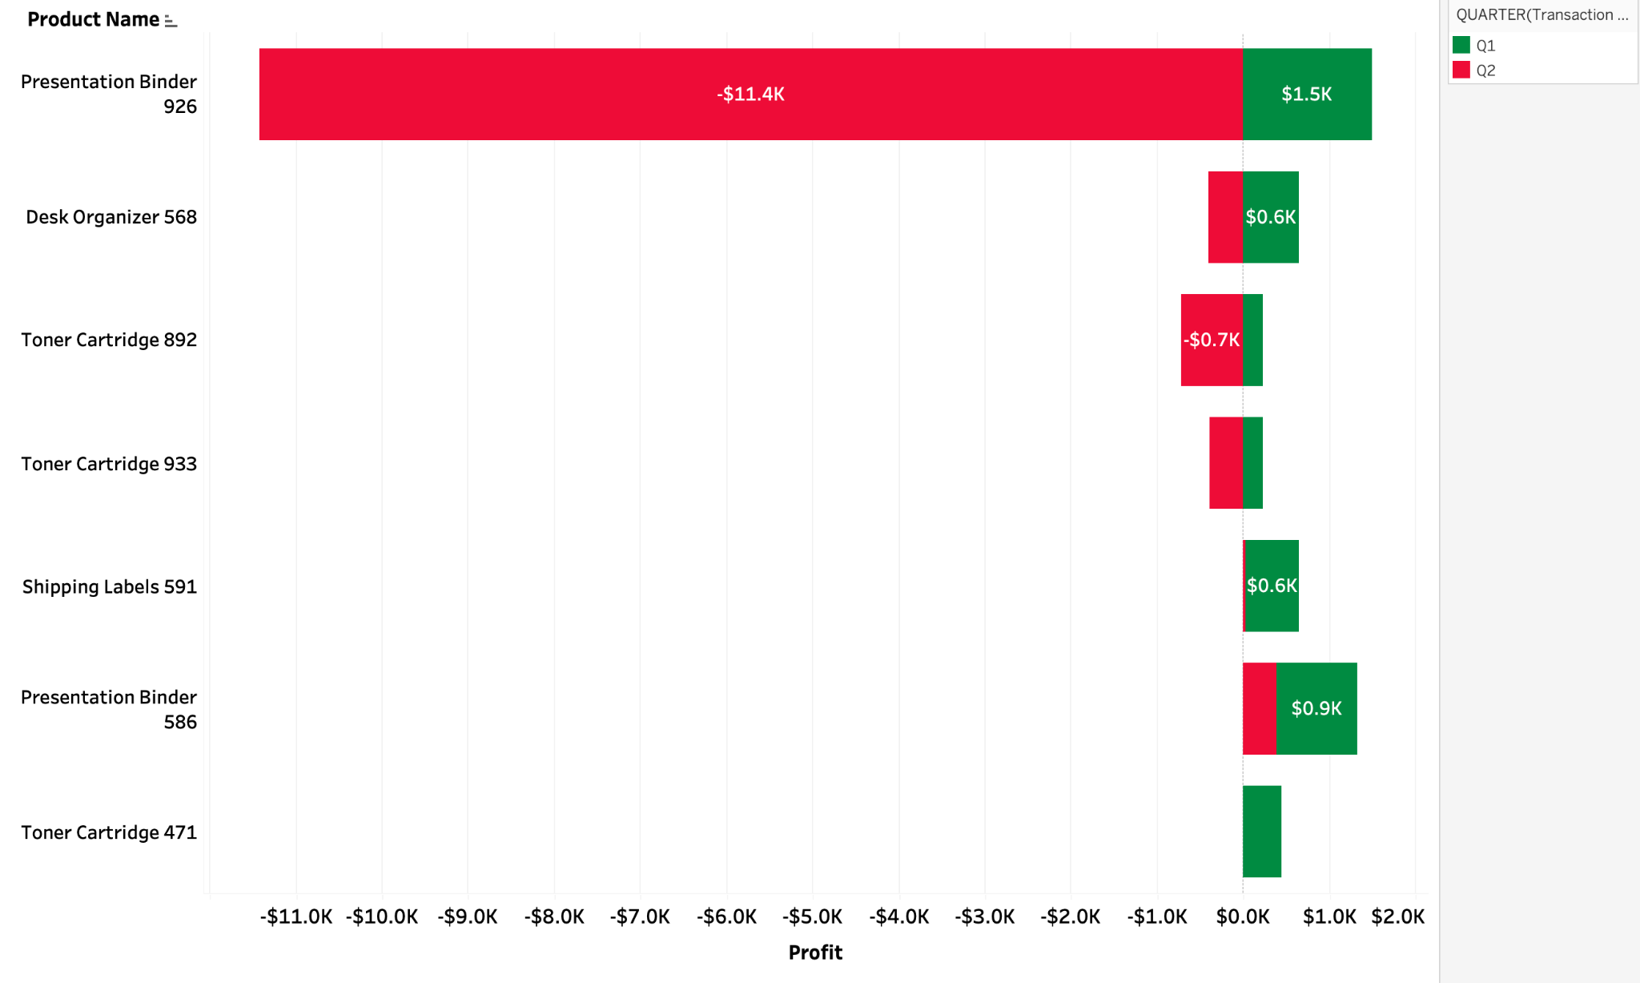
Key Insight
- South Office Supplies profitability deterioration was concentrated in a small number of products. Presentation Binder 926 was the largest negative contributor, shifting from approximately $1.5K profit in Q1 to an $11.4K loss in Q2.

Business Takeaway
- Historical Q2 growth in completed orders reversed sharply in 2026, accompanied by a substantial revenue decline and slightly weaker profit margin. Because the 2026 order decline occurred across all five product categories, the slowdown appears broad-based rather than isolated to a single category. Historical regional and product-level analysis also demonstrates that profitability issues can be concentrated in specific markets and products, reinforcing the need for targeted investigation alongside company-wide performance monitoring.

ACT
Business Problem #1

Recommendations
- Prioritize Software sales opportunities, particularly in the West, where Software generates $24.5M in revenue, $15.1M in profit, and a 61.7% profit margin.
- Evaluate Consulting profitability to determine why its revenue is close to Software while producing substantially less profit.
- Further investigate Mid-Market customers to determine whether this segment represents an opportunity for targeted sales growth.
- Track revenue, profit, and profit margin by product category and region to measure whether these actions improve performance over time.

Business Problem #2

Recommendations
- Implement category-specific discount controls rather than applying the same discount strategy across all product categories.
- Restrict discounts of 30% or more for Hardware and Office Supplies because these categories generated losses of approximately $36.2K and $106.5K, respectively, at the highest discount level.
- Maintain greater pricing flexibility for Software, Consulting, and Marketing Services since these categories remained profitable even at discounts of 30% or more, with Software showing the strongest profitability.
- Track revenue, profit, and profit margin by discount range and product category to measure whether revised discount policies improve profitability over time.

Business Problem #3

Recommendations
- Investigate the 2026 company-wide slowdown. Examine customer segments, sales channels, regions, and order behavior to determine what drove the Q2 decline across all five product categories.
- Separate revenue growth from profitability performance. Continue monitoring completed orders, revenue, profit, and profit margin together so increased sales activity is not automatically interpreted as stronger business performance.
- Use targeted intervention when profitability is concentrated. Review pricing, discounting, costs, and transaction activity for major product-level outliers, such as Presentation Binder 926, before implementing broad category-wide changes.

